School of Information Technologies

Faculty of Engineering & IT

**ASSIGNMENT COVERSHEET GROUP ASSIGNMENT**

**Unit of Study**: COMP5216 Mobile Computing

**Assignment name**: Quiz Game App

**Assignment group members:**

Zhiliang Wang, 460094203



**Abstract**

This app is going to be designed for learning basic programming concepts which will be efficient for users to gain programming knowledge and prepare exams. This project proposal aims to clarify the original idea and scheduled everything that will be done in this small app project. It includes five parts: **Background and Significance, Related Work on Quiz Apps, Problems and Solutions, Draft of Interface Design, Main Functions Overview, Techniques and Schedule, Reflections and Expectations**. In the Introduction and Objective, the motivation of this project and the purpose of the final app will be discussed. Through make a parallel analysis of similar quiz apps in apple store, the benefits of this app will be introduced. Also, the draft of user interface design will be explained in detail. In the end, the schedule of this project will be displayed.

Contents

Abstract 2

1 Background and Significance 4

2 Related Work on Quiz Apps 4

2.1 Quizlet(Inc, 2017) 4

2.2 Solo Learn(Python, 2017) 4

3 Problems and Solutions 5

3.1 Problems 5

**3.1.1 UI design problem** 5

**3.1.2 Coding problem** 5

3.2 Solutions 5

**3.1.1 UI design solutions** 5

**3.1.2 Coding solutions** 6

4 Interface of Quiz Game App 6

5 Main Functions Overview 10

6 Techniques and schedule 11

6.1 Involved techniques 11

**6.1.1 Developing tools** 11

**6.1.2 Design techniques** 11

7 Reflections and Expectations 12

8 References 13

**1 Background and Significance**

As a rookie of IT domain. I felt it was so hard to handle with the basic concepts of IT programming languages such as Java, Python, Nodejs and so on as well as some protocols and principles in network. I studied civil engineer before I came USYD, but I am so interested in learning new things in new area of IT. A quiz in game style that can also be called a mind sport can help students or spur them to attempt to answer questions in handset. In this way, rookies of IT could build confidence and motivation for learning boring theory.

**2 Related Work on Quiz Apps**

Before I create ‘Quiz app for IT rookies’, I have done a research about characteristics of good feedback which may the most important elements of improving productivity of learning new things. I will make a comparison with two apps in quiz subclass. All of them are free for users.

**2.1 Quizlet(Inc, 2017)**

In Quizlet, the users could practice and master knowledge more interesting. The users can create their own flashcards and study sets or choose from millions created by other students. More than 20 million students study with Quizlet each month that makes studying languages, history, vocabulary and science more simple and effective. Study are companying with charts, maps, images and figures.

**2.2 Solo Learn(Python, 2017)**

Solo learn collected 12 programming languages, including Python, HTML, CSS, JavaScript, C++, Java, PHP, SQL, Ruby, JQuery, C#, Swift. the users can learn all the programming languages listed above through interactive lessons, code in the mobile code playground, play with friends and peers, and discuss to learn or help others learn.

Two apps I mentioned before are both fantastic for users. But for Quizlet, developing images and cards is not suitable for learning IT. Coding stuff is the main points in IT domain. For Solo Learn, it provides a super fantastic interface for users to program in any mobile platform, which will be a very creative way to learn programming. But it does not provide more details in IT theory and no quiz after that which may be the only shortcoming for this app.

For my own app, its main purpose is that to agitate user’s interest on learning new things. I used three types quiz, which are ‘Multiple choices’, ‘Images quiz’ and ‘Right or wrong quiz’ to attract users to use it more often. I offered basic knowledge test and images to expand user’s vision on IT.

**3 Problems and Solutions**

**3.1 Problems**

**3.1.1 UI design problem**

UI colour and UI layout is difficult to arrange properly. It took me nearly one week to figure out how to imitate other beautiful UI designs and then code my project. For example, in the ‘image quiz’ part, I wanted to add images in my project and I had added all images in ‘images’ folder but I still could not see it in running app.

**3.1.2 Coding problem**

For a rookie in swift or even in programming domain, I feel it is hard to do anything smoothly. For example, when I want to add some extra functionalities in my app, it was hard for me to debug.

**3.2 Solutions**

**3.1.1 UI design solutions**

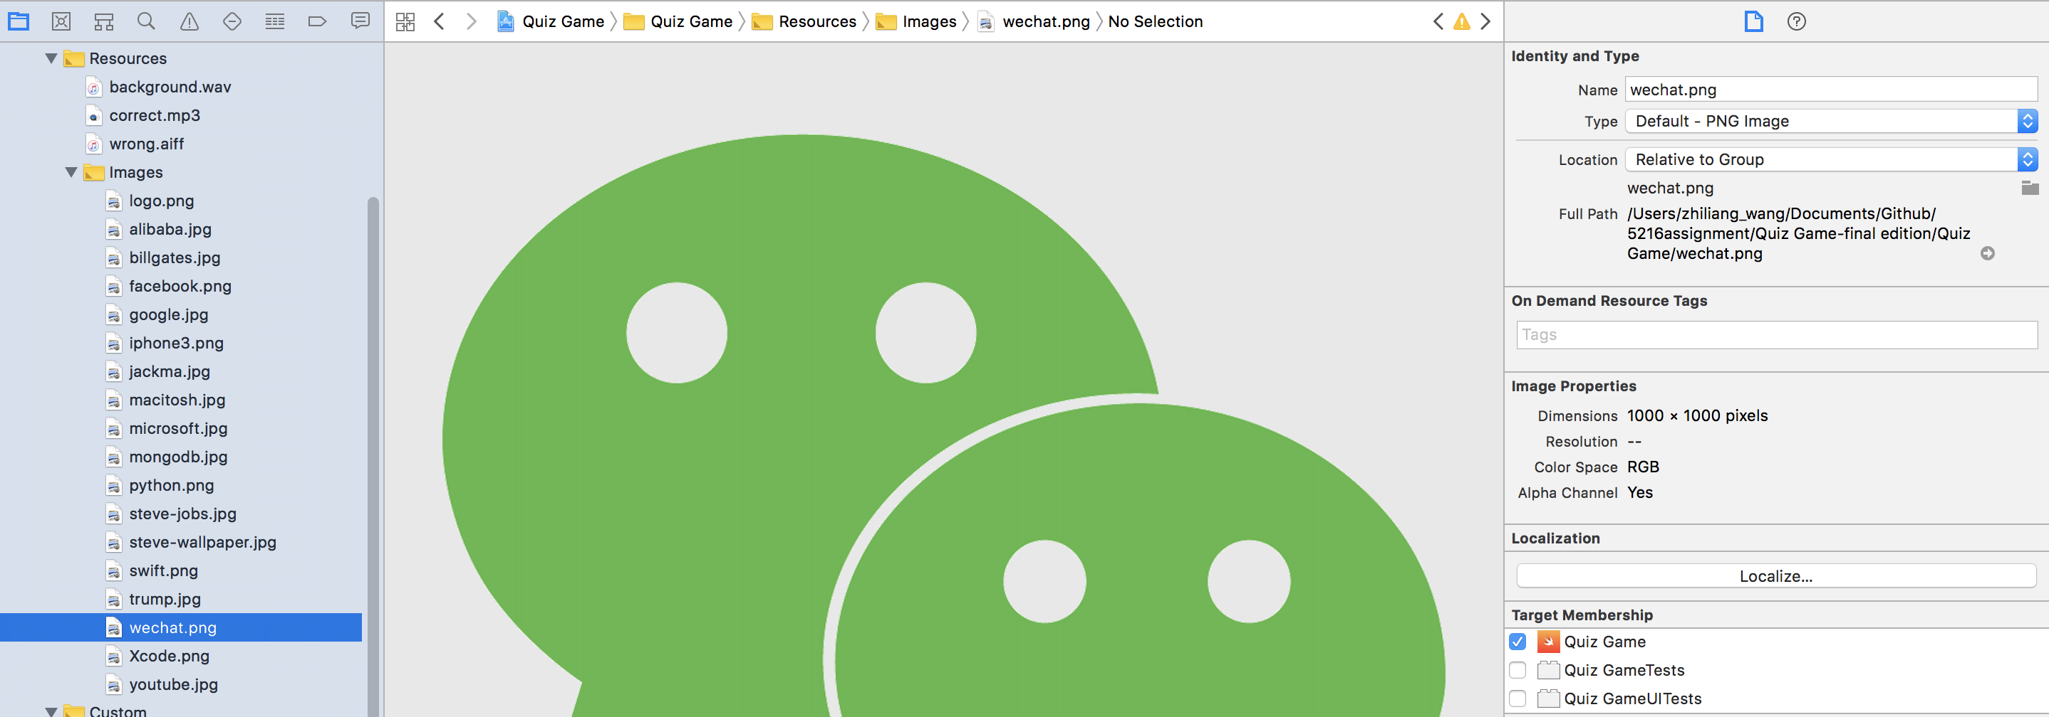

As it can be seen that I add ‘wechat.png’ in my project which belongs to ‘image quiz’ section but I did not tick ‘Quiz Game’ in ‘Target Membership’ column. It was really a tiny mistake, but it cost me two days to find a solution. I finally solved my problem by asking questions online. This is just one example of debug in the process of developing a new app.

**3.1.2 Coding solutions**

When I encounter a new problem in coding process, search it online is the best and fastest way to get correct solutions. For example, I found that to use right search phrase is so important to find nice answers. I can see so much codes on ‘stack overflow’, ‘Github’ and some other related websites. Through all this reviewing and analysis, I get familiar with swift and Xcode more and more.

**4 Interface of Quiz Game App**

|  |  |
| --- | --- |
| ../Introduction%20vedio/quiz-game-icon.jpeg | ../../../../Desktop/images/steve-jobs.jpg |
| Figure 4.1 Quiz Game app icon | Figure 4.2 Preparation to enter Homepage |
| ../Introduction%20vedio/quiz-options.jpeg | ../Introduction%20vedio/facebookLoginAuth.jpeg |
| Figure 4.3 Homepage | Figure 4.4 Login to Facebook |
| ../Introduction%20vedio/facebookLogin.jpeg | ../Introduction%20vedio/facebookShare.jpeg |
| Figure 4.5 Process Facebook account | Figure 4.6 Share on Facebook or Twitter |
| ../Introduction%20vedio/MultiChoiceQuiz.jpeg | ../Introduction%20vedio/MultiChoiceTapContinue.jpeg |
| Figure 4.7 Multiple choice question | Figure 4.8 Click right answer and tap to continue |
| ../Introduction%20vedio/ImageQuiz.jpeg | ../Introduction%20vedio/ImageQuizAnswer.jpeg |
| Figure 4.9 Question for image quiz | Figure 4.10 Choose the right answer and goes next |
| ../Introduction%20vedio/ImageQuizCorrectContinue.jpeg | ../Introduction%20vedio/RightOrWrongQuiz.jpeg |
| Figure 4.11 Show the result of answer | Figure 4.12 Right or Wrong question |
| ../Introduction%20vedio/RightOrWrongTap.jpeg | ../Introduction%20vedio/MultiChoiceScores.jpeg |
| Figure 4.13 Tap correct or wrong directly | Figure 4.14 Recent and Highscore inn ‘Multiple choice’ result recently |
| ../Introduction%20vedio/RightOrWrongScores.jpeg | ../Introduction%20vedio/ImageScores.jpeg |
| Figure 4.15 Recent and Highscore in ‘Right or wrong’ result recently | Figure 4.15 Recent and Highscore inn ‘Image quiz’ result recently |

**5 Main Functions Overview**

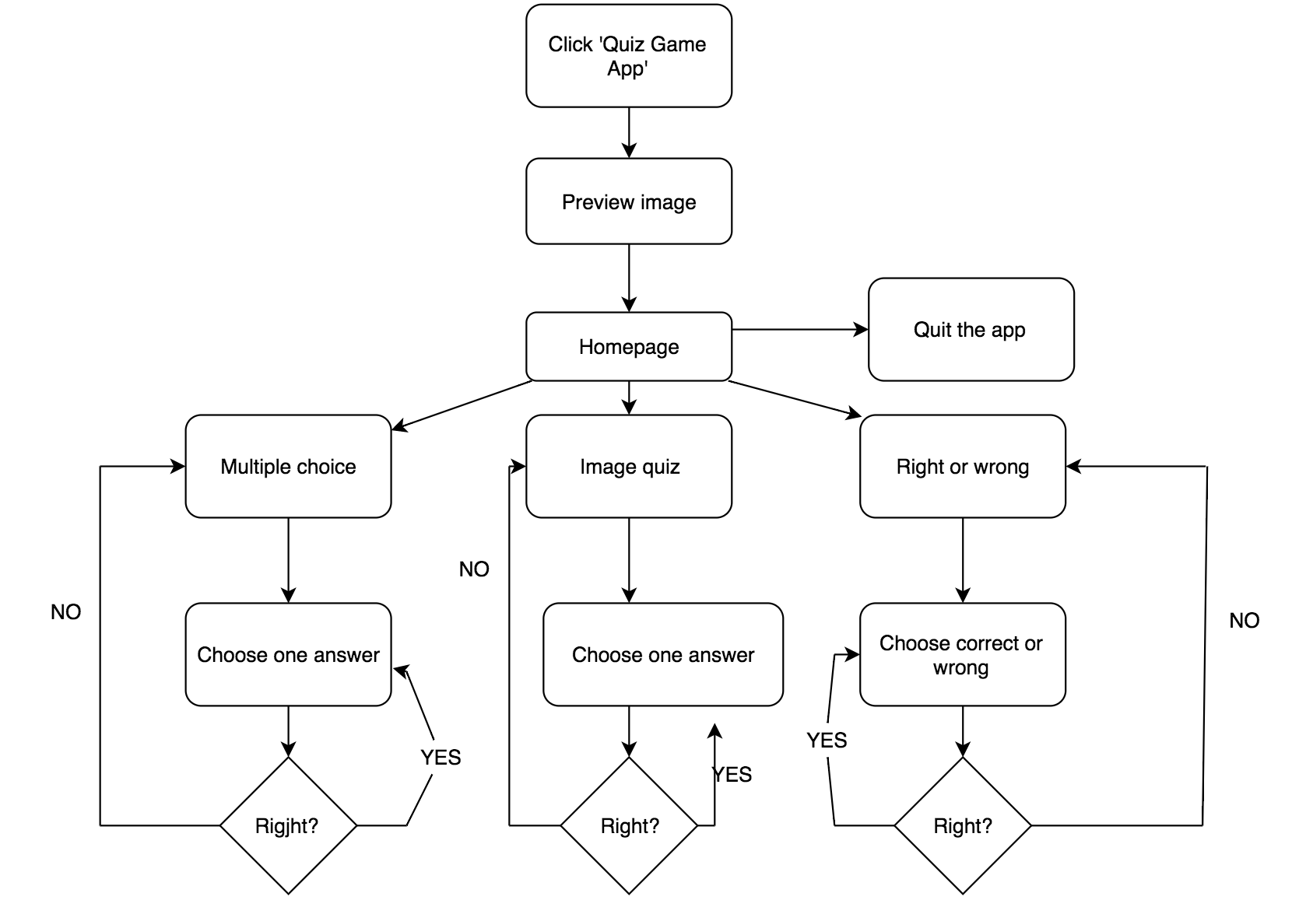

Figure 5.1 Logic flow of functionalities in the Quiz Game app

**6 Techniques and schedule**

**6.1 Involved techniques**

**6.1.1 Developing tools**

I used the newest Xcode 10.0 and swift 3.2 to develop this app.

**6.1.2 Design techniques**

Before I started this app, I read so many articles about layout and thought again and again on how to build a beautiful quiz app. With the faster changes on IPHONE’s inch, we have to consider the inch variable problems. In the Auto Layout tutorial (Easier Auto Layout, 2017), instead of using Interface Builder and storyboards, I created all constraints in code using layout anchors, and Facebook API has been delivered into project by Cocoapods. Creating constraints in my code helped to have a greater understanding of Auto Layout constraint relationships.

**7 Reflections and Expectations**

At the end of this semester, I have to submit my own project before due date. Compared with proposal I have submitted in week 05, most of functions I designed cannot be implemented smoothly by my limited knowledge in IOS developing. Maybe this is the gap between product manager and IOS developer. I think in the future career, I will encounter the same situation that proposal would not be perfectly matched by implementation process. To be honest, handling a simple IOS application is not an easy job by one person. I found that writing a beautiful and clear proposal is easy, but how to use techniques to make it come true is harder. Through one semester’s learning of swift and IOS, I obtained so much from this course, such as bright visions in the lecture, solid developing skills in tutorial, debugging independently I project etc. I was a totally stranger to everything in starting up a new IOS app. Reading different documents about coding and follow the steps of tutorial training in designing UI are both hard for me. Finally, I finished a IOS app without runtime bug. This achievement has special meaning for me. From front-end to back-end programming, there are lots of things to do and too much nutrients to absorb in the future. I believe the experience of developing this quiz game app, I can equip with lots of skills of independently solve problems in developing new software which will benefits my future career in IT domain.

**8 References**

Design Code: Design iOS 10 apps with Sketch and Swift 3. (2017). *Designcode.io.* Retrieved 3 September 2017, from https://designcode.io/iosdesign Facebook for Developers. (2017). *Facebook for Developers.* Retrieved 4 September 2017, from https://developers.facebook.com/

TutorialsPoint. (2017). *www.tutorialspoint.com.* Retrieved 3 September 2017, from https://www.tutorialspoint.com/java/java_online_quiz.htm

Python, L., & Inc., S. (2017). Learn to Code with Python on the App Store. *App Store.* Retrieved 4 September 2017, from https://itunes.apple.com/au/app/learn-to-code-with- python/id953972812?mt=8 Inc, Q. (2017). Quizlet on the App Store.

Development - Create 4 Quiz Apps with Swift 3 & iOS 10. (2017). *Udemy*. Retrieved 3 September 2017, from https://www.udemy.com/ios-development-create-4-quiz-apps-with- swift-3-ios-10/

The Swift Programming Language (Swift 4): About the Language Reference. (2017). *Developer.apple.com.* Retrieved 3 September 2017, from https://developer.apple.com/library/content/documentation/Swift/Conceptual/Swift_Programming_Language/AboutTheLanguageReference.html#//apple_ref/doc/uid/TP40014097-CH29- ID345

Xcode - Support - Apple Developer. (2017). *Developer.apple.com.* Retrieved 3 September 2017, from https://developer.apple.com/support/xcode/

Auto Layout Guide: Working with Constraints in Interface Builder. (2017). Developer.apple.com. Retrieved 20 October 2017, from https://developer.apple.com/library/content/documentation/UserExperience/Conceptual/AutolayoutPG/WorkingwithConstraintsinInterfaceBuidler.html#//apple_ref/doc/uid/TP40010853-CH10-SW1

Easier Auto Layout: Coding Constraints in iOS 9. (2017). Ray Wenderlich. Retrieved 20 October 2017, from https://www.raywenderlich.com/125718/coding-auto-layout

Working with Auto Layout Visual Format Language and Programmatically Creating Constraints. (2016). Appcoda.com. Retrieved 20 October 2017, from

https://www.appcoda.com/auto-layout-programmatically/